Teresa Fischer

COS2005 Python Programming

Professor Luke Snell

11/8/2024

Flowchart Employee Class # 3:

Class:

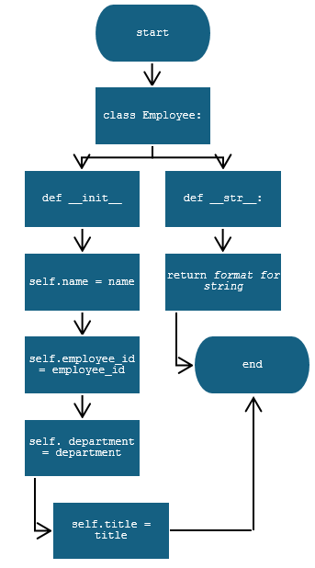

Mainline: